**ARDUPILOT**

**Ardupilot is an open source Autopilot system.**

**Introduction**

Ardupilot is the most advanced, full-featured and reliable open source autopilot software available. It has been under development since 2010 by a team of diverse professional engineers and computer scientists. It is the only autopilot software capable of controlling almost any vehicle system imaginable, from conventional airplanes, multirotors, and helicopters, to boats and even submarines. And now being expanded to feature support for new emerging vehicle types such as quad-planes and compound helicopters.

**ArduPilot** was originally developed by hobbyists to control model aircraft and rovers and has evolved into a full-featured and reliable autopilot used by industry, research organisations and amateurs.

**Objectives**

To Learn Ardupilot Software for designing Autonomous flying software for drones and programme their missions.

To Learn about Cygwin,MAV Proxy etc and using them for creating a virtual Simulation.

To use Mission Planner to set up a virtual drone and learn how to plan a mission using it.

To use the software for simulating a mission on SITL .

To Learn how to control a Quadcopter using a transmitter.

**Project Requirements**

* Installation of SITL software
* Installation of Mission Planner Software with SITL running in it
* Knowledge about basic Aeromodelling
* Basic knowledge about Ardupilot
  + **Important Timeline**
* Project started with the introduction to ***IMU*** .

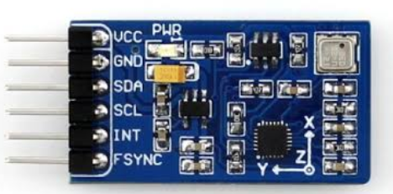

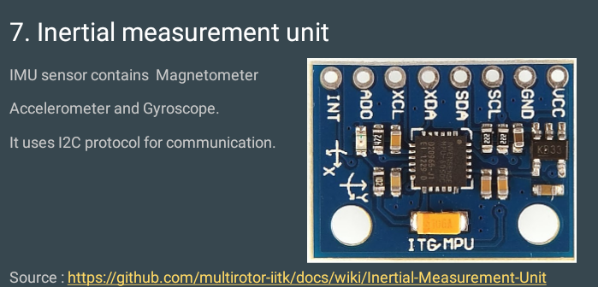

* + - Understanding the working, importance and installation of ***Flight*** ***Controller*** (FC),which is considered to be the brain of aircraft.

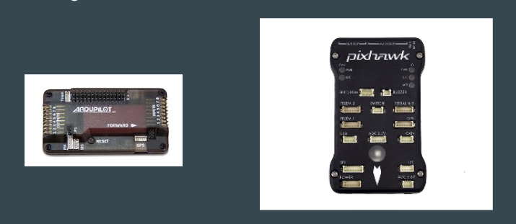

* Introduction to ***Ardupilot***.

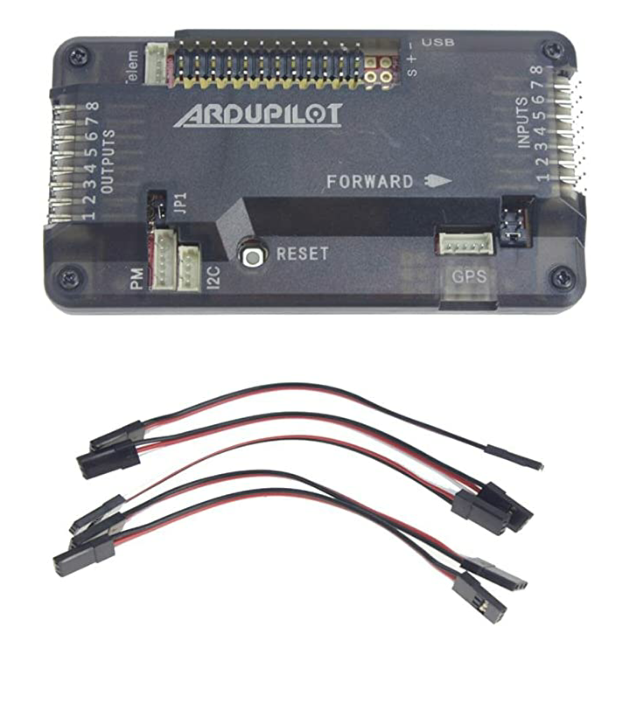

* Installation of ***simulator-software-in-the-loop (SITL)***.
* Installation of mission planner and running sitl into it.

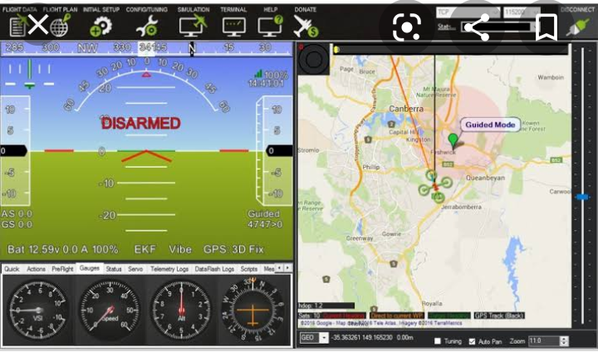

* Evaluation through MCQ and Short-answer type test.
* Understanding the controlling of Quadcopter using a transmitter.

Till now, it is great experience to practice on mission planner and understand the working of

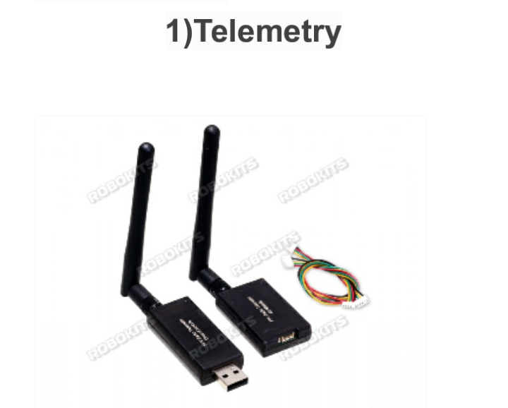 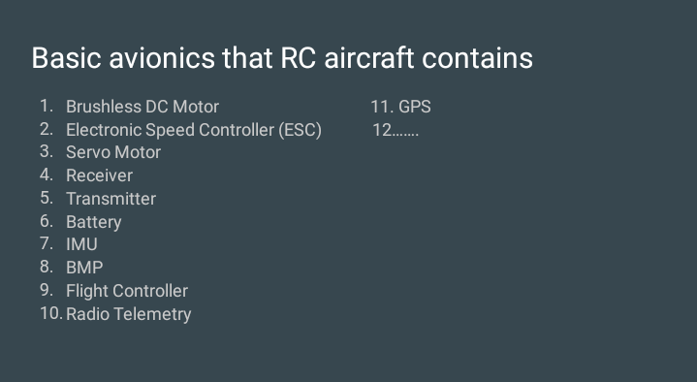

**ESC Electronic speed controller**

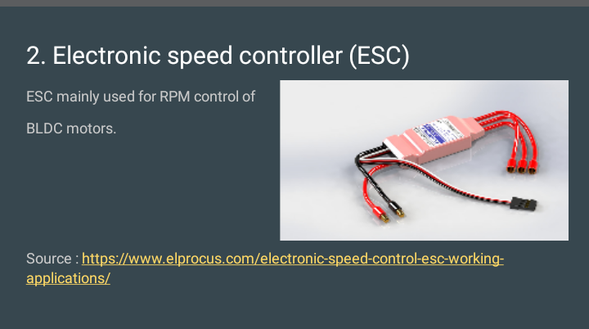

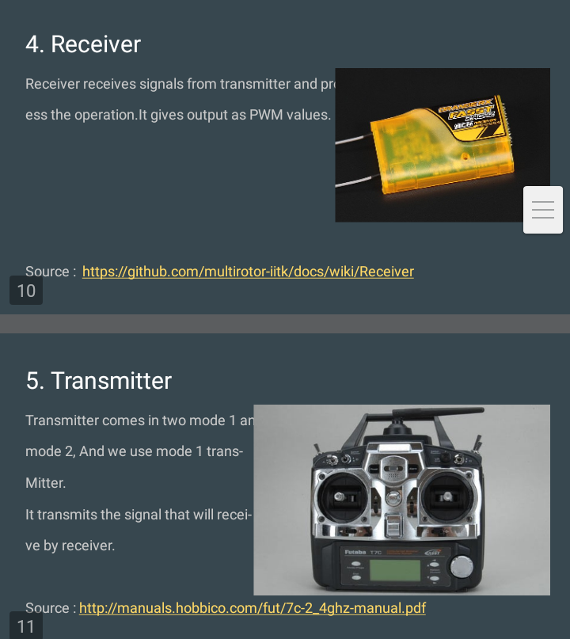

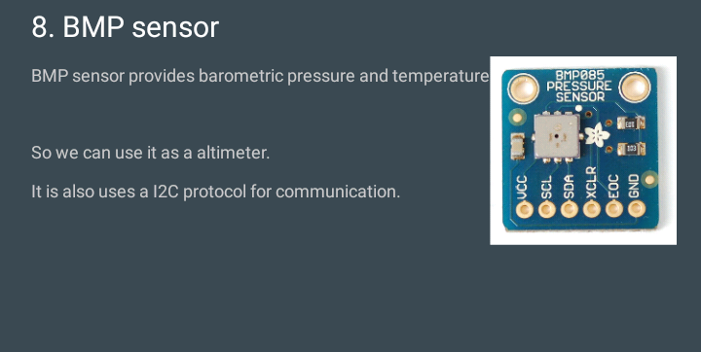

* Understanding the working, importance and installation of ***Flight*** ***Controller*** (FC),which is considered to be the brain of aircraft.



**Pixhawk**

* **These flight controllers are well equipped with a variety of sensors and well suited for autonomous flight.**
* **Pixhawk is highly recommended for general use where sensor redundancy is desired and flexible external expansion.**
* **If UAV is a fixed wing, then Pixhawk or Pixhawk cube are uses for better stabilization purpose .**

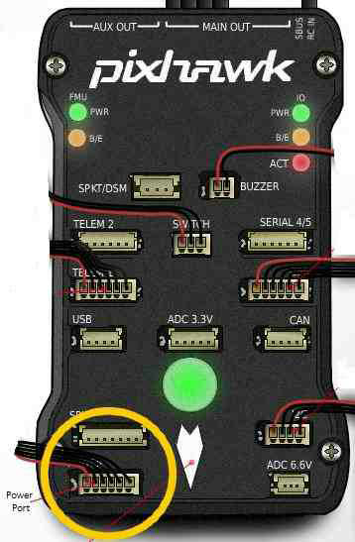

**Source: ardupilot.org**

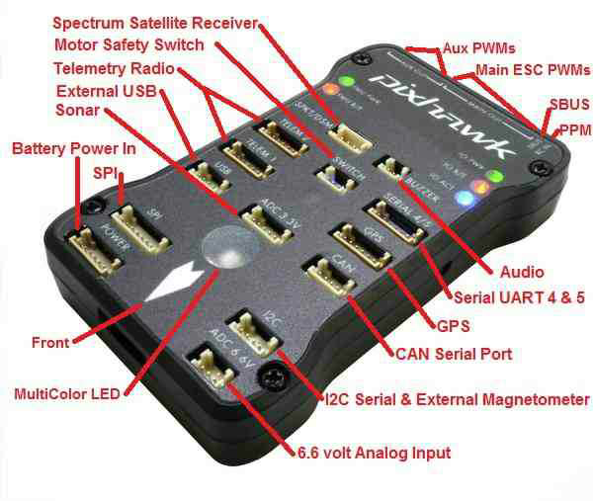

**Source: ardupilot.org**

* ***simulator-software-in-the-loop (SITL)***.

The SITL (software in the loop) simulator allows you to run Plane, Copter or Rover without any hardware. It is a build of the autopilot code using an ordinary C++ compiler, giving you a native executable that allows you to test the behaviour of the code without hardware.



SITL can simulate:

* multi-rotor aircraft
* fixed wing aircraft
* ground vehicles
* underwater vehicles
* camera gimbals
* antenna trackers
* a wide variety of optional sensors, such as Lidars and optical flow sensors

**Controllers**

A drone controller works by sending a radio signal from the remote control to the drone, which tells the drone what to do.

There are four movements:

* Roll
* pitch
* yaw
* throttle

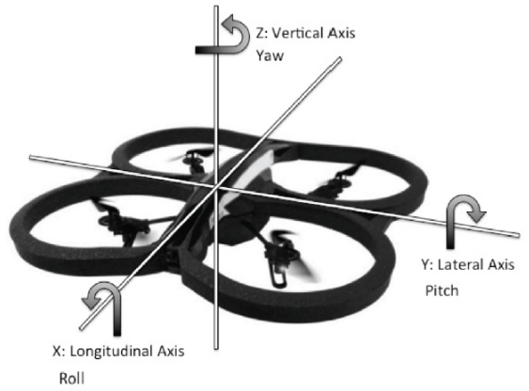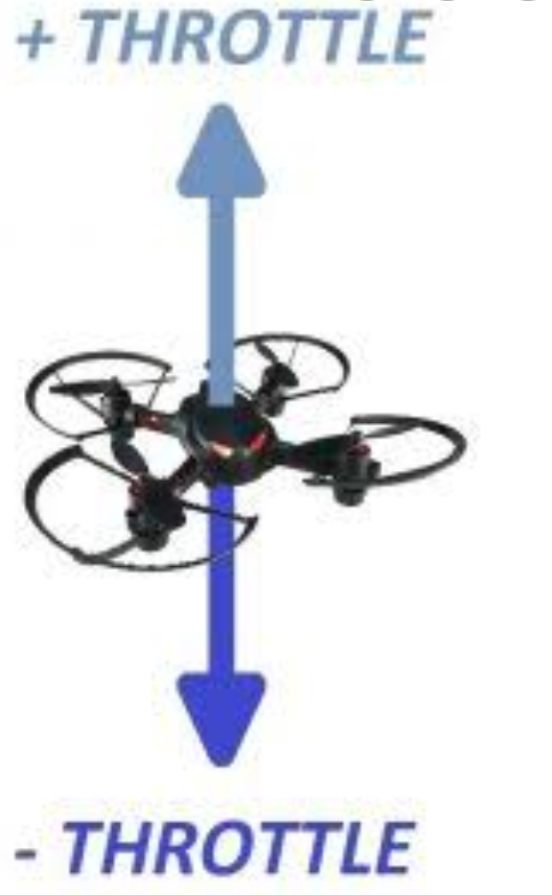

***Right Stick:***The right stick lets you control the roll and pitch of your drone, allowing you to move the drone right/left as well as forward and backward.

***Left Stick:***The left stick lets you control the yaw and throttle of your drone, allowing you to control the height at which you fly and letting you rotate the drone clockwise or counterclockwise in flight.

***Trim Buttons***:Each drone remote controller has its own trim Buttons.

*If you notice your drone tilting toward one direction when you first start flying this probably means it needs to be trimmed. You can use the corresponding trim button to correct the balance as needed.*

**Future Goals**

Our future goal is to implement whatever we have learnt through this on Hardware when we reach the campus. Moreover our recent goal is to implement ardupilot on a virtual drone using Mission Planner.